

National Textile University
Department of Computer Science
Subject: Mobile Application Development

Submitted to: Sir Rehan Sarwar

Submitted by: Maha

Reg. number: 23-NTU-CS-1170
Lab 1 (home task)
Semester:6th

Task:
Create another button for decrementing counter value along with increment button
Code:
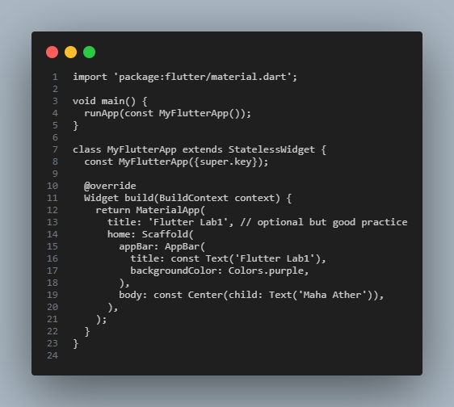
Terminal:
